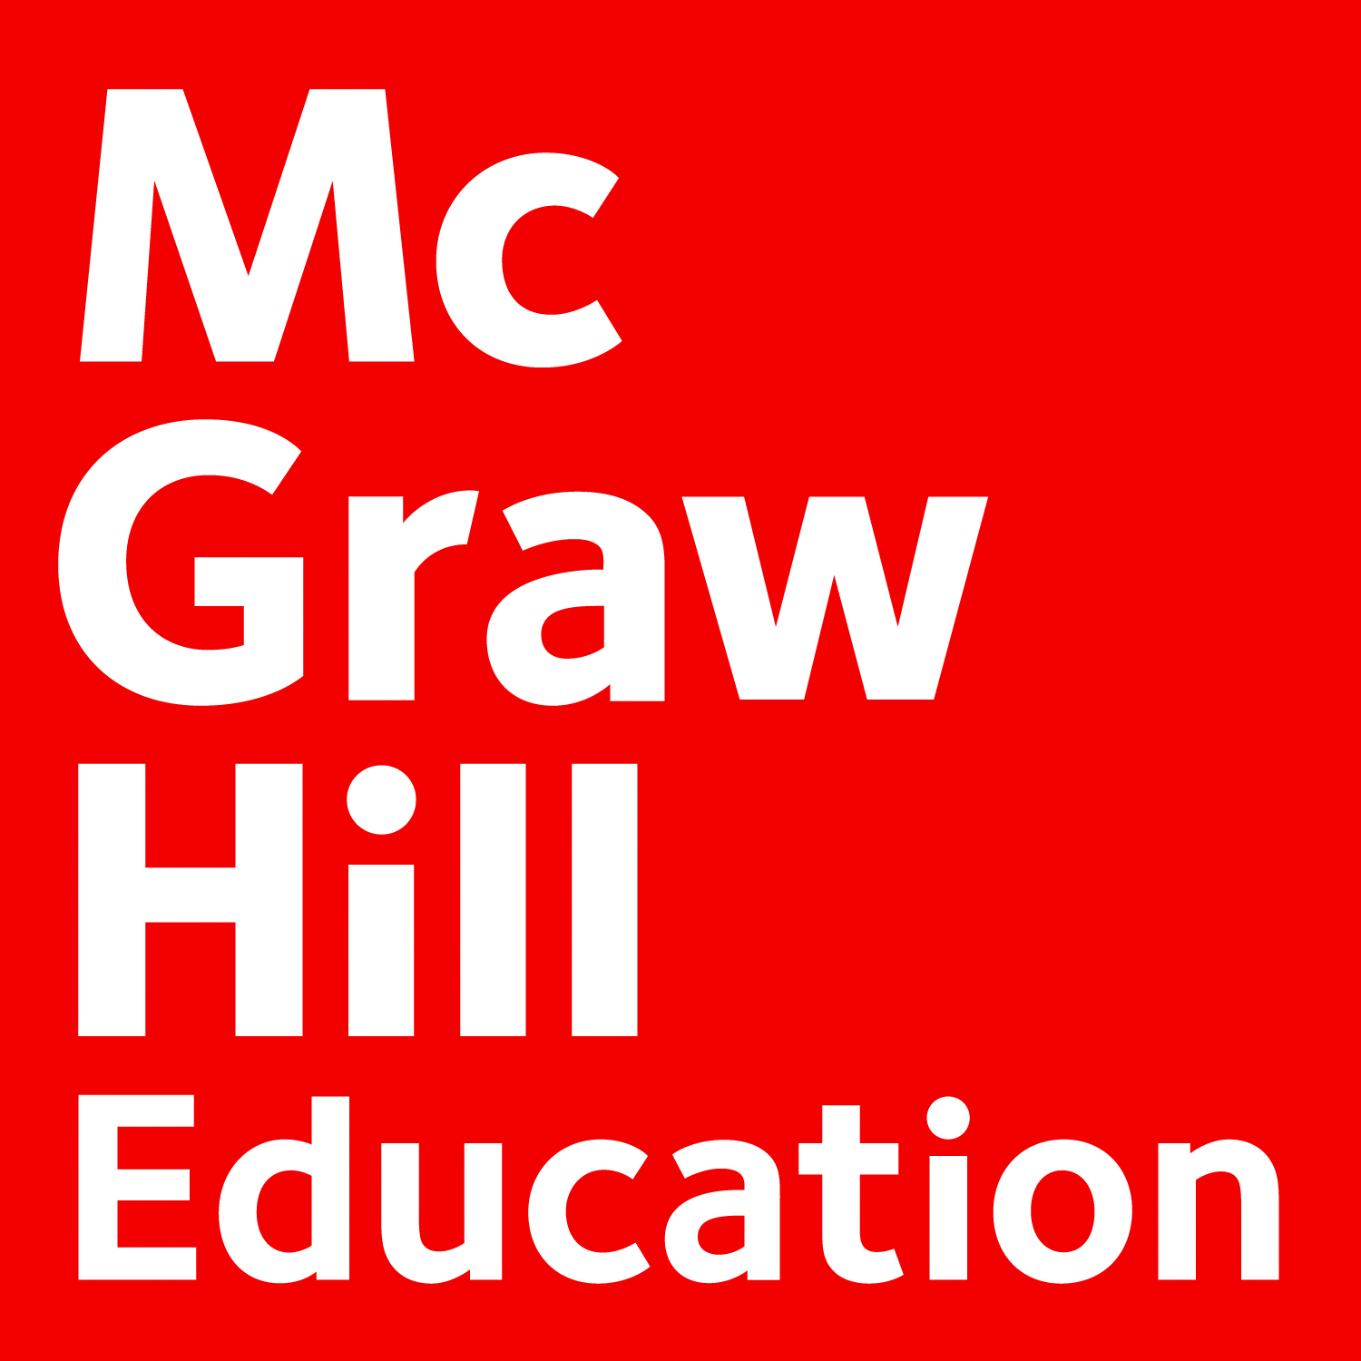

McGraw Hill Education SUPPLIER INFORMATION PORTAL

Introduction and Overview
Dear Suppliers,
Welcome to the McGraw Hill Education Supplier Information Portal! McGraw-Hill Education is utilizing the Ariba Spend Management software and the Ariba Network (AN) to electronically transact business with its suppliers. This portal provides information for all suppliers that are conducting business with McGraw Hill Education via the Ariba Network (AN). Your customer selected Ariba as their electronic transaction provider and will use the Ariba Network to exchange business documents with suppliers, including purchase orders, contracts, notifications, shipping information and invoices (purchase orders, purchase order confirmations and advance shipment notices, invoices, and credit memos.

Additional information regarding this project is included in the invitation letter from McGraw Hill Education, as well as on this portal. As part of McGraw Hill Education’s ongoing policy to continuously improve efficiency and service quality to customers and suppliers alike, they are currently implementing the next stage of their overall electronic strategy to move away from paper based financial transaction processing.

What information are you looking for?

 | I’m new to Ariba
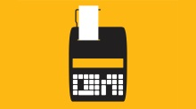 | Do I need to pay anything?
 | Where can I find training materials?
 | I want to find new business partners
 | I need to upload a catalog
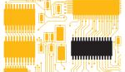 | I want to integrate my ERP system to Ariba
 | I need to contact someone from Ariba
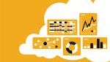 | Useful links

Back to top
I’m new to Ariba

Ariba Network is the leading business network with over one million trading partners in 190 countries transacting more than 450 billion dollars (USD) annually. Join the Ariba Network to transact electronically with your customers and find new business opportunities.

Next Steps
- Register on the Ariba Network. Follow the instructions you have received from the MHE Support team and link to the step by step instructions on the registration process if needed.
- Connect with McGraw Hill Education through your Ariba account. After registration is complete, ensure that you have accepted the Relationship Request with McGraw Hill Education in the Customer Relationships area of your account.
- Configure your Ariba account. Ensure that your account is configured to <Customize per project> receive purchase orders and send invoices in the manner that can be supported by your organization.
- Create a Test account. Creating a Test account will allow you to become familiar with McGraw Hill Education’s processes in a Test environment prior to moving into the live (Production) environment.
- Review training materials. Located below you will find McGraw Hill Education’s training materials to assist you with the tasks listed above. You will be invited to attend training in the coming weeks if you need more help with these processes.

Account Access
- Login to the Ariba Network: http://supplier.ariba.com

Ariba Video Tutorials (available on http://supplier.ariba.com)
- Introduction to the Ariba Network
- Getting Started on the Ariba Network
- Introduction to the Seller Collaboration Console
- Handling Purchase Orders
- Creating a PO-Based Invoice (Introduction)
- Creating an Invoice (Advanced Topics)
- Creating and Publishing Catalogs

Back to top
Pricing - Supplier Membership Program
Suppliers that are new to the Ariba Network, generally start transacting for free, though based on the volume of transactions you do – with McGraw Hill Education, as well as with other buyers on the Network – there may eventually be fees associated with your use. These fees will be billed by and payable to Ariba.

With higher subscription levels, the features and benefits expand – to help your e-commerce program drive more sales, collaboration, automation, and competitive differentiation through:
- value-added functionality
- commerce management tools and training
- catalog and connectivity solutions
- technical support
- project management resources

There are two components to the Supplier Membership Program: the Network Transaction Service Fees and the Subscription Fees.

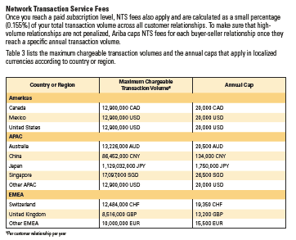
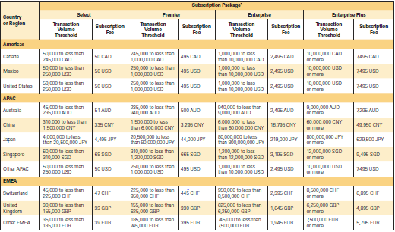

For more information about the Ariba Supplier Membership program and regional pricing, please go to the Supplier Membership Program website, or check out this datasheet.

Back to top
General Supplier Education

Ariba User Community
Provides general help and FAQs for suppliers looking to setup/manage your Ariba account. To access Ariba's Help and Documentation, go to http://supplier.ariba.com, click the Help menu and select Help Center.

Ariba Network for Sellers live demos
Ariba offers online training sessions:
- Introduction to Ariba Network, Ariba Network Functional Demo, and more: Register here for these live, interactive demo sessions held multiple times per month.
  - AN Value Webinar: 1st and 3rd Wednesday at 11AM EDT
  - Functional Training: 2nd and 4th Wednesday at 11AM EDT
- Seller Summits Provide link

McGraw Hill Education-Specific Supplier Education Materials

Account & Transactions Management Guides
The following manuals contain compulsory instructions, as well as tips regarding the management of your Ariba Network account when transacting with McGraw Hill Education:
- Account Configuration guide
- PO Management Guide
- Invoice Guide

Back to top
Ariba Discovery
Ariba Discovery is the business matchmaking service that helps you find leads among thousands of large companies on the Ariba Network. Every day, thousands of buyers from the world’s leading companies use this buyer-seller matching service while sourcing goods and services. After your registration, you're automatically notified whenever a buyer is looking for the kind of products or services you offer.
Ariba Discovery can help you increase sales by:
- Matching you with buyers that want what you offer
- Automatically sending you high quality leads
- Making your bidding process more efficient
- Helping you comply with companies’ purchasing processes
- Boosting awareness among your target customers

Go to http://www.ariba.com/solutions/sell/discovery-for-sellers to discover new business opportunities.

Back to top
Catalogs
Catalogs are text files stored on the Ariba Network (CIF catalogs) or on your own company’s or third party’s website (PunchOut catalogs) that describe the products and services your organization offers and the prices you charge. You can create catalogs for any product or service, regardless of how it is measured, priced, or delivered. Your customers access your catalogs through their procurement applications to see product and service offerings and buy from you. Catalogs are the main communication channel between you and your customers. Access Catalog Guides for Suppliers from Help section at your Ariba Network account. You may also download these documents for your catalog type:
- CIF Catalog Guide
- PunchOut Catalog Guide

The United Nation Standard Products and Services Codes need to be used during the creation of your catalog. These codes describe the Products and Services categories. The latest version of the codes classification can be found through the following link: UNSPSC code 13.5
Note:
- Buyer will indicate which suppliers are required to have a catalog.
- CIF catalogs can be created with any word processor, text editor, or any spreadsheet application.

Catalog Testing
All suppliers transacting through the Ariba Network using catalogs will be required to test with McGraw Hill Education. Find out more about test account creation in Account Configuration guide.

Back to top
ERP Integration
The Ariba Network offers possibility to integrate with your back-end ERP system for automatic exchange of electronic documents. For more information please review below guides.

Technical Specifications, documentation and examples:
- EDI Guide
- cXML User's Guide
- Ariba cXML Solutions Guide

Integration Testing
All suppliers transacting through the Ariba Network using one of the following integration methods will be required to test with McGraw Hill Education:
- cXML Transactions
- EDI Transactions
Find out more about test account creation in Account Configuration guide.

Back to top
Supplier Support
Supplier Support during enablement
- Ariba Network Registration or Configuration Support
Please contact Customer Support 866.312.7422 for any questions regarding registration, configuration, Supplier Membership Program fees, or general Ariba Network questions.

- McGraw Hill Education Business Process Support
Please contact the McGraw Hill Education Supplier Enablement team:
  - General questions email: MHESupplierP2P@mheducation.com
  - For Payment Inquires email: MHE.AccountsPayable@mheducation.com

Supplier Support post Go-Live
- By web form:
  - Go to http://supplier.ariba.com
  - Click the Help link in top right corner and then Help Center.
  - Go to section Support and search for any topic you would like to know more about.
  - If none of the articles answers your query, click on Create Online Service Request button.
  - Completely fill out the web form and submit.
- By telephone:
  - Europe / Middle East / Africa: +44 20 7187 4185
  - Europe / Middle East / Africa: 00 800 2222 7422 (toll free number for France, Germany, Italy, Netherlands, Spain, Sweden, Switzerland & UK)
  - USA/Canada: 1-866-312-7422 (toll free)
  - North/South America: +1 412 222 6170
  - Asia Pacific: +65 6311 4585

Other
- Username & Password recovery
Go to http://supplier.ariba.com and click on the Forgot Username or Forgot Password link in login section. Ariba will forward an email to the email address on record on the Ariba Network after Username/Password recovery request was submitted, for the protection of your company information.
- EDI/cXML Support Contact
If you are transacting POs to McGraw Hill Education via EDI or cXML, you can get direct assistance from Ariba. Send an email to Ariba's technical team at AskAribaTech@ariba.com. Ariba will respond to your email directly. Please ensure that the Subject field of the email references McGraw Hill Education.

Back to top

Useful Links
Ariba Network Terms of Use
Data Policy
Security Disclosure
Legal notices

