Register as a New User

1. Click Register Now.
2. Enter Company Information fields marked required with an asterisk (*) including:
• Company Name
• Country
• Address
3. Enter User Account information marked required with an asterisk (*) including:
• Name
• Email Address
• Username (if not the same as email address)
• Password
4. Accept the Terms of Use by checking the box.
5. Click Register to proceed to your home screen

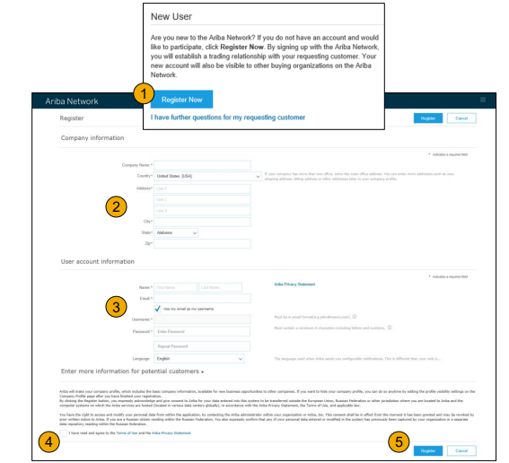
Accept Relationship as an Existing User
- Log in using your current Ariba username and password to accept the relationship with Air Canada
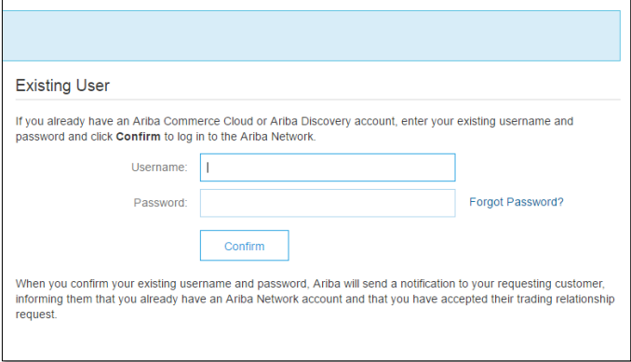

Complete Your Profile
1. Select Company Profile from the Company Settings dropdown menu.
2. Complete all suggested fields within the tabs to best represent your company.
3. Fill the Public Profile Completeness meter to 100% by filling in the information listed below it.

Note: The more complete a profile, the higher the likelihood of increasing business with existing and prospective customers.


