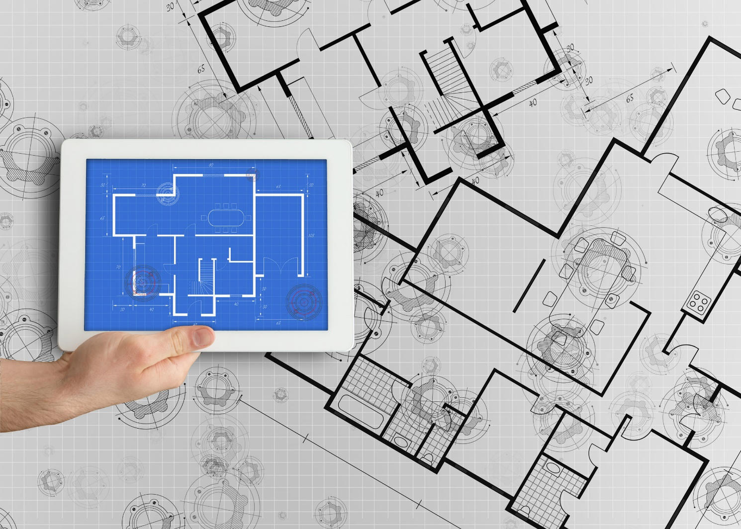

Government of Alberta
Integrated Seller Transaction Guideline – NAMER
June 2020


Table of Contents
Version History 3
Government of Alberta Mapping Requirements and Deltas 4
government of alberta Detailed Specifications and Requirements 5
Scope 6
Purchase Order Details 6
Order Confirmation Details 7
Ship Notice Details 7
Invoice Details 7
Supplemental Documentation 9
Ariba Network Support Information 10

Version History
This log is updated each time this Process Document is updated. The log identifies the version number, the date the version was completed, the author of the changes, and a brief description of the changes.

Version | Date | Author | Description
1.0 | 6/2/2020 | Nick Wasylik, Senior Seller Integrator | Initial Version of Document
1.1 | 6/10/2020 | Nick Wasylik, Senior Seller Integrator | Update structure of contacts in EDI Delta
1.2 | 6/15/2020 | Nick Wasylik, Senior Seller Integrator | Revising specifications as per Accenture feedback
SAP STATEMENT OF CONFIDENTIALITY AND EXCEPTIONS
The contents of this document shall remain the confidential property of SAP and may not be communicated to any other party without the prior written approval of SAP. This document must not be reproduced in whole or in part. It must not be used other than for evaluation purposes only, except with the prior written consent of SAP and then only on condition that SAP’s and any other copyright notices are included in such reproduction. No information as to the contents or subject matter of this proposal or any part shall be given or communicated in any manner whatsoever to any third party without the prior written consent of SAP.
The furnishing of this document is subject to contract and shall not be construed as an offer or as constituting a binding agreement on the part of SAP to enter any relationship. SAP provides this document as guidance only to estimate costs and time-scales of the predicted delivery project. This will be subject to confirmation prior to any contractual or delivery commitment by SAP.
SAP warrants that to the best of its knowledge those who prepared this material have taken all reasonable care in preparing it and believe its contents to be true as at the date of this document. SAP cannot however warrant the truth of matters outside of its control and accordingly does not warrant the truth of all statements set out in this document to extent that such statements derive from facts and matters supplied by other persons to SAP. The statements in this document are qualified accordingly.

Government of Alberta Mapping Requirements and Deltas

Deltas
In the following excel workbooks you will find baseline cXML and EDI transactions accepted by the Ariba Network with the additional requirements for Government of Alberta noted in red.

cXML Delta: EDI Delta:
The following is a summary of the requirements that are unique to Government of Alberta’s procurement environment, as detailed in the Excel Delta’s document.

Purchase Order Specifics (Tab 1)
- Payment terms will be sent on all POs, which must match on invoice if returned
- ShipTo addresses and IDs will be sent at both header and line-level
- BillTo address and ID will be sent on all POs, required to be returned on invoices
- Non-catalog POs will include supplier part ID as “Not Available”
- Advanced Pricing Details/Price Basis Quantity may be sent, must be returned on invoice

Invoice Specifics (Tab 2)
- Required addresses and IDs: From, Ship From, Ship To with ID, Bill To with ID and Sold To
- Strict Address Validation is enforced – Must provide complete and appropriate address information on invoices
  - Invoice Addresses should be returned where they are received, either at Header or Line Level
- Payment terms NOT required to be returned on invoices, but if sent, must match PO
- Discounts may be entered at the Header Level
- Non-PO invoices are not supported
- Part IDs must match to PO
- Tax is not supported through the Ariba Network
- Shipping and Special Handling charges are not supported – Will be included as PO line items if needed
- Invoices may not be back-dated or future-dated
- Invoices numbers can be reused only for Failed invoices

Service Invoice (Tab 2a)
- Service Entry Sheets are auto-generated from service invoices
- Multiple invoices are supported for an amount-based service item

Order Confirmation Specifics (Tab 3) – Optional
- Shipping and Delivery dates are optional for Order Confirmation
- Suppliers can change Part IDs on Order Confirmation
- Suppliers cannot change Advanced Pricing Details
- Suppliers cannot Reject orders on Order Confirmation

Ship Notice Specifics (Tab 4) – Optional
- Estimated or actual shipping dates are required for Ship Notice
- Ship Notice Type is required
- Delivery and transport information may be added
- Packing slip IDs must be unique on each Ship Notice

Line Level Credit Memo (Tab 5)
- Header Level and Line Level Credit Memos are supported
- Line Level Credit Memo supported via Quantity or Price adjustment
- A reason for the credit is required

Extrinsic Fields (Tab 6)
- A summary of all extrinsic fields in scope can be reviewed here
- No extrinsic fields are required to be returned on an invoice

Transaction Validation Rules

Please note, Goverment of Alberta has configured custom validation rules on the Ariba Network which apply specifically to POs, Order Confirmations, Ship Notices, PO based Invoices and Credit Memos. Review these settings from your supplier account on the Ariba Network.

Goverment of Alberta Detailed Specifications and Requirements

Scope

Government of Alberta Prod ANID: AN01422170924
Government of Alberta Test ANID: AN01422170924-T

Required Transactions
  - Purchase Order
  - Invoice

Optional Transactions
  - Order Confirmation
  - Advanced Ship Notice

Purchase Order Details

Purchase Order Types Supported | Purchase Order Types Not Supported
New POs | Blanket POs (BPO’s)
Change/cancel POs
Non-catalog POs
POs with attachments
Service POs
Table 1 - Purchase Order Types Supported/Not Supported

Ship To Address

  - GoA PO will send Ship To address at either Header or Line Level
  - GoA PO will contain Ship To address IDs, which can include ad-hoc address IDs.

Order Confirmation Details

Government of Alberta does NOT require Order Confirmation. Supported methods of providing them are:
  - cXML
  - EDI
  - Online
  - Email to requestor outside of Ariba Network

Ship Notice Details

Government of Alberta does NOT require Advanced Ship Notices. Supported methods of providing them are:
  - cXML
  - EDI
  - Online
  - Email to requestor outside of Ariba Network

Invoice Details

Invoice Types Supported | Invoice Types Not Supported
Individual Detail Invoice: applies against a single PO referencing line items; line items may be material items or service items. | Non-PO Invoice: invoice against PO not transacted via the Ariba Network
Partial invoice: Invoice against a portion of the items on a PO. | Non-PO invoice against contract or master agreement
Invoice against material PO | Invoice against Blanket PO
Invoice against service PO | Line level credit supported by negative quantity at item level and positive unit price
lineLevelCreditMemo (cXML 1.2.018 and higher) invoice purpose set to “lineLevelCreditMemo” | Header Credit Memo
 | Debit Memo
 | Invoice against PCard
 | Header Invoice: single invoice applying to single PO without item details
 | Duplicate Invoice: invoice numbers may be reused in case of failure of original invoice
Table 2 - Invoice Types Supported/Not Supported

Tax Requirements

- Tax is not supported via the Ariba Network

- A summary tax amount is required on all invoices even though the amount is zero dollars.

Remit To Address Information

- Remit To Address information is not required on the invoice

NOTE: Strict address validation is enforced. When this rule is enabled, the system will check if the following cXML elements are present and if it has a value:

- Name
- PostalAddress.Street
- PostalAddress.City
- PostalAddress.State
- PostalAddress.PostalCode
- PostalAddress.Country isoCountryCode attribute

Shipping and Special Handling Fees

  - Shipping and special handling charges are NOT supported at either line level or summary level

  - Shipping and special handling will be built into unit price of line item

Line Level Validation

- The following line level data cannot be changed from PO to Invoice.
  - Currency for Unit Price
  - Unit Price
  - Unit of Measure
  - Item Quantity Overage
  - Part Number
Buyer configured Allowances and Charges

- None: Allowances and Charges are out of scope

Supplemental Documentation

This document contains Government of Alberta specific information regarding transaction requirements. Information in this document does NOT cover the complete technical aspects of integrating with the Ariba Network. Below are two sections for supplemental documentation to be used with this document for EDI or cXML transaction formats. Only refer to the section that pertains to the format your organization with be sending/receiving from the Ariba Network (EDI or cXML).

cXML Section for Supplemental Documentation
New cXML supplier to Ariba Network must:
- Support a DTD (document type definition) validation tool internally and download the document type definitions (DTD’s) for all supported transactions.
- Support HTTPS protocol. Ariba supports HTTPS (not HTTP) only for cXML transactions.
- Review the cXML Solutions Guide and cXML User Guides.
cXML Document Type Definitions (DTD’s):
- http://cxml.org Download InvoiceDetail.zip for the InvoiceDetailRequest.dtd.
- http://cxml.org Download cXML.DTD for the OrderRequest
- http://cxml.org Download Fulfill.dtd for ConfirmationRequest/ShipNoticeRequest

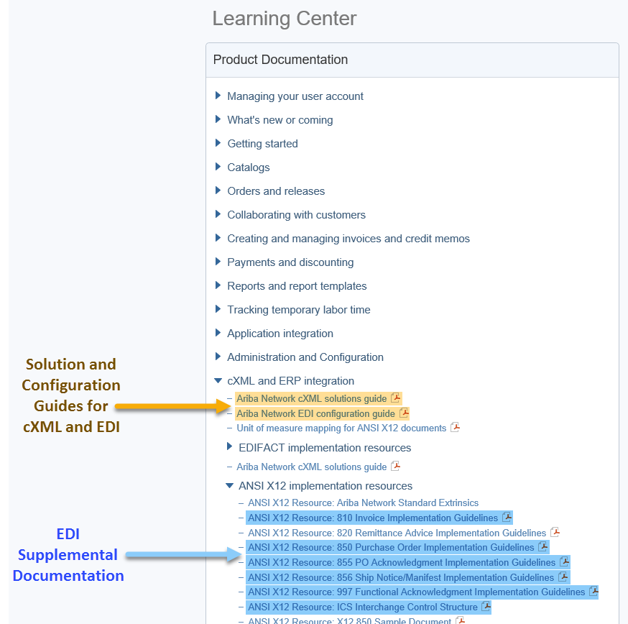
Recommended Resources: Please log into your supplier account on the Ariba Network in order to access the cXML and EDI solution and configuration guides as well as supplemental EDI documentation. The steps for accessing this information is outlined below.

- Log into your supplier account on the Ariba Network.
https://supplier.ariba.com
- Select Help Center >>
- Select Documentation
- Expand cXML and ERP Integration

Within the cXML and ERP Integration section, you will see the cXML and EDI solution and configuration guides. Based on your selected integration method, please download the appropriate document.
- Ariba cXML Solutions Guide
- Ariba Network EDI Configuration Guide

Supplemental EDI Documentation
To access the supplementation EDI documentation, proceed to step 5.
- Expand ANSI X12 implementation resources

Within the ANSI X12 implementation resources section, you will find supplemental EDI documentation for the following EDI documents:
- 850 Purchase Order Implementation Guidelines
- 810 Invoice Implementation Guidelines
- 855 PO Acknowledgment Implementation Guidelines
- 856 Ship Notice/Manifest Implementation Guidelines
- 997 Functional Acknowledgment Implementation Guidelines
- ICS Interchange Control Structure (Ariba Production and Test Interchange ID Details)

Ariba Network Support Information

Supplier Integration Specialist (SIS) support is available to Government of Alberta suppliers. SIS support is available during the test phase and two weeks post-go live with Government of Alberta or until the first production transactions are exchanged. After that period, suppliers must leverage Ariba Technical Support for any production issues. To contact SI support, send an email to askaribatech@ariba.com. Be sure to list Government of Alberta in the subject line of the email.
Depending on your transaction volume across all Buyers on the Ariba Network you will be automatically subscribed to a Supplier Membership Program Subscription. These subscriptions provide your organization access to many premium features and services that are exclusively available to members at these levels. The Premier, Enterprise, and Enterprise Plus levels provide ongoing technical electronic document support. To find out more go to:
http://www.ariba.com/assets/uploads/documents/Datasheets/SMP_Subscription_Datasheet.pdf.
To find out your Program Subscription, log on to https://supplier.ariba.com, click the Property Navigator toolbar on the upper right corner of the page and select Service Subscriptions in the drop down box.
Until subscribed to one of Ariba’s support programs, limited assistance regarding account registration, access and configuration is available from Ariba:

By Web:

If you can log into your Ariba Network Account | If you cannot log into your account
- Login at http://supplier.ariba.com  - Once logged in, click on the ‘Help’ link located on the upper right hand side of the page and choose Help Center.  - Select Support located in the top right hand side of the page.  - Options in the bottom right hand side of the page are Live Chat or By Phone.  - An Online Service Request can also be submitted by selecting the “Start” button in the top center of the page. | - Go to http://supplier.ariba.com  - For login issues select the “Forgot Username” or “Forgot Password” links near the top of the page.  - Fill out the web form and select the Submit button.

