

Integrated Seller Transaction Guideline
December 2020


Table of Contents
Version History 3
PASSHE Mapping Requirements and Deltas 5
PASSHE Detailed Specifications and Requirements 6
Scope 6
Purchase Order Details 6
Order Confirmation Details 7
Ship Notice Details 7
Invoice Details 7
Supplemental Documentation 10
Ariba Network Support Information 11

Version History
This log is updated each time this Process Document is updated. The log identifies the version number, the date the version was completed, the author of the changes, and a brief description of the changes.

Version | Date | Author | Description
1.0 | 9/9/2015 | Ariba, an SAP Company | Initial Version of Document
1.1 | 1/8/2016 | Suzanne Hooper | Updated Formats and Branding
1.2 | 1/27/2016 | Chris Frazier | Removed Extraneous (duplicate) Pages
1.3 | 3/23/2016 | Katelyn Hood | 15s Updates
1.4 | 5/12/2016 | Tammie Burns | Updated of new support phone number
1.5 | 6/7/2016 | Tammie Burns | Updated Supplemental Documentation links
1.6 | 8/1/2016 | Allison Briggs | Removed Information Only Invoice
1.7 | 12/7/2020 | Keith Gelini | Added Customer-Specific Requirements
SAP STATEMENT OF CONFIDENTIALITY AND EXCEPTIONS
The contents of this document shall remain the confidential property of SAP and may not be communicated to any other party without the prior written approval of SAP. This document must not be reproduced in whole or in part. It must not be used other than for evaluation purposes only, except with the prior written consent of SAP and then only on condition that SAP’s and any other copyright notices are included in such reproduction. No information as to the contents or subject matter of this proposal or any part shall be given or communicated in any manner whatsoever to any third party without the prior written consent of SAP.
The furnishing of this document is subject to contract and shall not be construed as an offer or as constituting a binding agreement on the part of SAP to enter into any relationship. SAP provides this document as guidance only to estimate costs and time-scales of the predicted delivery project. This will be subject to confirmation prior to any contractual or delivery commitment by SAP.
SAP warrants that to the best of its knowledge those who prepared this material have taken all reasonable care in preparing it and believe its contents to be true as at the date of this document. SAP cannot however warrant the truth of matters outside of its control and accordingly does not warrant the truth of all statements set out in this document to extent that such statements derive from facts and matters supplied by other persons to SAP. The statements in this document are qualified accordingly.

PASSHE Mapping Requirements and Deltas

Deltas
In the following excel workbooks you will find baseline cXML and EDI transactions accepted by the Ariba Network with the additional requirements for PASSHE noted in red.

cXML Delta: <insert cXML Excel Deltas Doc here> EDI Delta: <Embed the EDI Excel Deltas Doc here>
The following is a summary of the requirements that are unique to PASSHE’s procurement environment, as detailed in the Excel Delta’s document.

Purchase Order Specifics (Tab 1)
- Payment terms will be sent on all POs
- Ship to address will be sent at the header level
- Ad Hoc ship to addresses are in scope

Invoice Specifics (Tab 2)
- Required addresses and IDs: Ship From, Ship To, Bill To, Remit To
- Payment terms are not required on invoices, but must match PO if included
- Line item descriptions are required on all invoices
- Invoices cannot be back-dated more than 3 days

Order Confirmation Specifics (Tab 3)
- Delivery dates are required for Order Confirmation

Ship Notice Specifics (Tab 4)
- Delivery dates are required for Ship Notice
- Actual or estimated shipping dates are required on ship notice

Credit Memo (Tab 5)
- Header or line level credit memos are allowed

Transaction Validation Rules

Please note, PASSHE has configured custom validation rules on the Ariba Network which apply specifically to POs, BPOs, Order Confirmations, Ship Notices, PO based Invoices, and non-PO based Invoices. Review these settings from your supplier account on the Ariba Network.

PASSHE Detailed Specifications and Requirements

Scope

PASSHE Prod ANID: AN01525385575

PASSHE Test ANID: AN01525385575-T

Required Transactions
  - Purchase Order
  - Invoice

Optional Transactions
  - Order Confirmation
  - Advanced Ship Notice

Purchase Order Details

Purchase Order Types Supported | Purchase Order Types Not Supported
New POs
Change/cancel POs
Non-catalog POs
POs with attachments
Blanket POs (BPO’s)
Service POs
Table 1 - Purchase Order Types Supported/Not Supported

Ship To Address

  - PASSHE PO will send Ship To address at header level
  - PASSHE PO will / will not contain Ship To address IDs. <Indicate how supplier to obtain ID’s to address match up if customer providing>

Order Confirmation Details

PASSHE does not require Order Confirmation. Supported methods of providing them are:
  - cXML
  - EDI
  - Online

Ship Notice Details

PASSHE does not require Advanced Ship Notices. Supported methods of providing them are:
  - cXML
  - EDI
  - Online

Invoice Details

Invoice Types Supported | Invoice Types Not Supported
Individual Detail Invoice: applies against a single PO referencing line items; line items may be material items or service items. | Non-PO Invoice: invoice against PO not transacted via the Ariba Network
Partial invoice: Invoice against a portion of the items on a PO. | Non-PO invoice against contract or master agreement
Invoice against material PO | Invoice against PCard
Invoice against service PO | Cancel Invoice
Invoice against Blanket PO | Header Invoice: single invoice applying to single PO without item details
Line level credit supported by negative quantity at item level and positive unit price
lineLevelCreditMemo (cXML 1.2.018 and higher) invoice purpose set to “lineLevelCreditMemo”
Header Credit Memo
Debit Memo
Duplicate Invoice: invoice numbers may be reuse in case of reject/fail/cancel of original invoice
Table 2 - Invoice Types Supported/Not Supported

Tax Requirements ** PASSHE Is Tax Exempt **

- Tax is supported at the line level or summary level or both.

- A summary tax amount is required on all invoices even if that amount is zero dollars.

Remit To Address Information

  - Customer will provide the Remit-To addresses to suppliers as part of the on-boarding process. Invoices will be rejected that have incorrect Remit-To.

  - Remit-To configuration may be viewed in the Settlement configuration section of your supplier account on AN.

  - Suppliers should notify Customer of any changes to their Remit-To address information.

Shipping and Special Handling Fees

  - Shipping and special handling charges are supported at the summary level.

Line Level Validation
- The following line level data cannot be changed from PO to Invoice.
  - Currency for Unit Price
  - Unit Price (10% Tolerance)
  - Unit of Measure
  - Item Quantity Overage (10% Tolerance)

Supplemental Documentation

This document contains PASSHE specific information regarding transaction requirements. Information in this document does NOT cover the complete technical aspects of integrating with the Ariba Network. Below are two sections for supplemental documentation to be used with this document for EDI or cXML transaction formats. Only refer to the section that pertains to the format your organization with be sending/receiving from the Ariba Network (EDI or cXML).

cXML Section for Supplemental Documentation
New cXML supplier to Ariba Network must:
- Support a DTD (document type definition) validation tool internally and download the document type definitions (DTD’s) for all supported transactions.
- Support HTTPS protocol. Ariba supports HTTPS (not HTTP) only for cXML transactions.
- Review the cXML Solutions Guide and cXML User Guides.
cXML Document Type Definitions (DTD’s):
- http://cxml.org Download InvoiceDetail.zip for the InvoiceDetailRequest.dtd.
- http://cxml.org Download cXML.DTD for the OrderRequest
- http://cxml.org Download Fulfill.dtd for ConfirmationRequest/ShipNoticeRequest

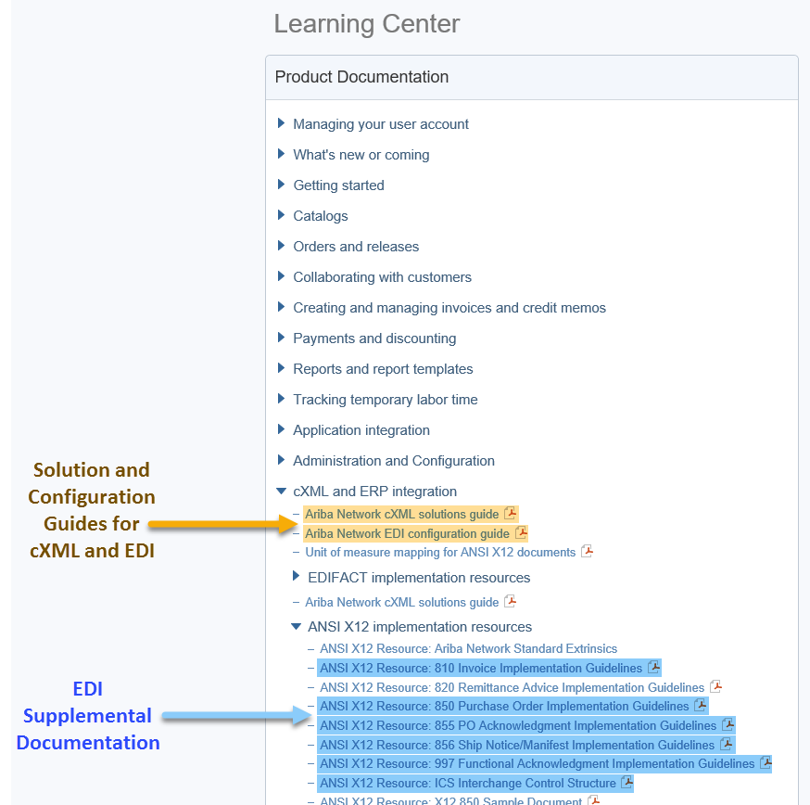
Recommended Resources: Please log into your supplier account on the Ariba Network in order to access the cXML and EDI solution and configuration guides as well as supplemental EDI documentation. The steps for accessing this information is outlined below.

- Log into your supplier account on the Ariba Network.
https://supplier.ariba.com
- Select Help Center >>
- Select Documentation
- Expand cXML and ERP Integration

Within the cXML and ERP Integration section, you will see the cXML and EDI solution and configuration guides. Based on your selected integration method, please download the appropriate document.
- Ariba cXML Solutions Guide
- Ariba Network EDI Configuration Guide

Supplemental EDI Documentation
To access the supplementation EDI documentation, proceed to step 5.
- Expand ANSI X12 implementation resources

Within the ANSI X12 implementation resources section, you will find supplemental EDI documentation for the following EDI documents:
- 850 Purchase Order Implementation Guidelines
- 810 Invoice Implementation Guidelines
- 855 PO Acknowledgment Implementation Guidelines
- 856 Ship Notice/Manifest Implementation Guidelines
- 997 Functional Acknowledgment Implementation Guidelines
- ICS Interchange Control Structure (Ariba Production and Test Interchange ID Details)

Ariba Network Support Information

Supplier Integration (SI) support is available to PASSHE suppliers. SI support is available during the test phase and two weeks post-go live with PASSHE, or until the first production transactions are exchanged. After that period, suppliers must leverage Ariba Technical Support for any production issues. To contact SI support, send an email to askaribatech@ariba.com. Be sure to list PASSHE in the subject line of the email.
Depending on your transaction volume across all Buyers on the Ariba Network you will be automatically subscribed to a Supplier Membership Program Subscription. These subscriptions provide your organization access to many premium features and services that are exclusively available to members at these levels. The Premier, Enterprise, and Enterprise Plus levels provide ongoing technical electronic document support. To find out more go to:
http://www.ariba.com/assets/uploads/documents/Datasheets/SMP_Subscription_Datasheet.pdf.
To find out your Program Subscription, log on to https://supplier.ariba.com, click the Property Navigator toolbar on the upper right corner of the page and select Service Subscriptions in the drop down box.
Until subscribed to one of Ariba’s support programs, limited assistance regarding account registration, access and configuration is available from Ariba:

By Web:

If you can log into your Ariba Network Account | If you cannot log into your account
- Login at http://supplier.ariba.com  - Once logged in, click on the ‘Help’ link located on the upper right hand side of the page and choose Help Center.  - Select Support located in the top right hand side of the page.  - Options in the bottom right hand side of the page are Live Chat or By Phone.  - An Online Service Request can also be submitted by selecting the “Start” button in the top center of the page. | - Go to http://supplier.ariba.com  - For login issues select the “Forgot Username” or “Forgot Password” links near the top of the page.  - Fill out the web form and select the Submit button.

