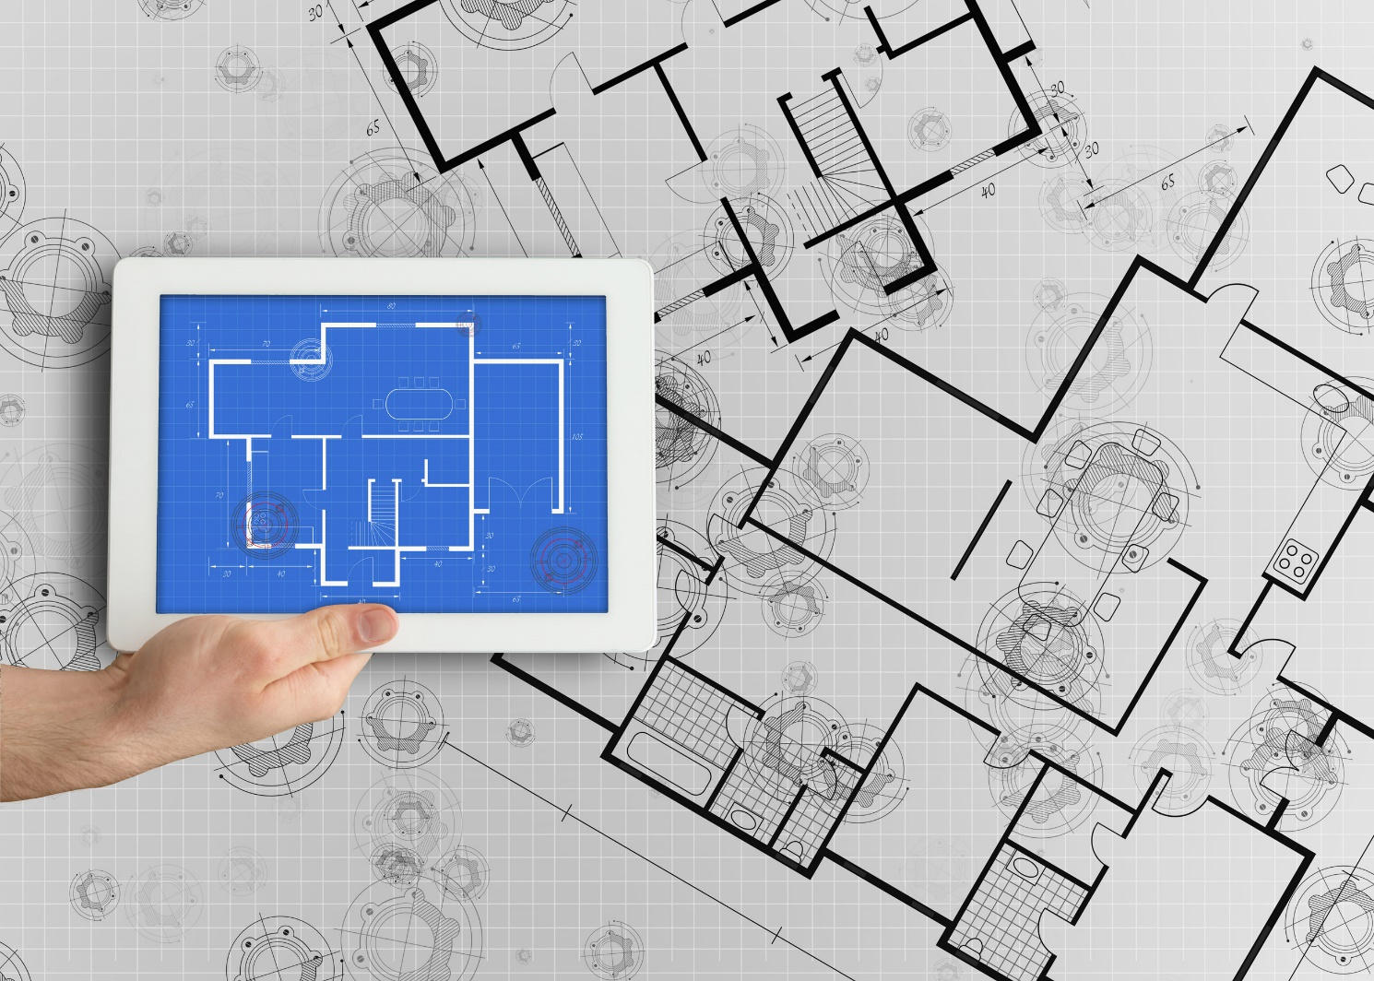

Integrated Supplier Transaction Guideline
June 2022

INTERNAL



Table of Contents
Version History 3
The Coca-Cola Company Mapping Requirements and Deltas 4
The Coca-Cola Company Detailed Specifications and Requirements 5
Scope 5
Purchase Order Details 5
Invoice Details 6
Supplemental Documentation 9
Ariba Network Support Information 10

Version History
This log is updated each time this Process Document is updated. The log identifies the version number, the date the version was completed, the author of the changes, and a brief description of the changes.

Version | Date | Description
1.0 | 06/2022 | Angie Albertson, SAP -- Initial Version of Document

The Coca-Cola Company Mapping Requirements and Deltas

Deltas
In the following excel workbooks you will find baseline cXML and EDI transactions accepted by the Ariba Network with the additional requirements for The Coca-Cola Company.

cXML Delta: EDI Delta:
The following is a summary of the requirements that are unique to The Coca-Cola Company’s procurement environment, as detailed in the Excel Delta’s document.
Purchase Order Specifics (Tab 1)
- Change POs are in scope
- Catalog, Non-Catalog, and Blanket orders are in scope
- Non-Catalog orders may use item description
- Ship To address will be sent at the header level and will contain Ship To IDs
  - Multiple Ship To will be sent at line level
- Payment terms will be sent on all POs
- Ad Hoc Ship To addresses will be used
- Tax can be sent on PO but does not have to match on Invoice

Invoice Specifics (Tab 2)
- Partial Invoices allowed
- Invoice Numbers can have a max length of 16 characters
  - Special Characters not allowed
  - Invoice numbers can be reused when the status is, rejected or failed.
- Non-PO Invoices not in scope
- Ship To ID and Address Required
- Ship From address required
- Payment terms cannot be changed but can be omitted
- Backdating and future-dating not allowed
- Item Descriptions Required
- Shipping and Special Handling are supported at Summary level
- Tax is supported at both line level and summary level.

Credit Memo (Tab 5)
- Line Level Credit memo is in scope
- Reason for Credit is required
- Reference to original invoice recommended
- Contains negative quantity and summary amounts with positive unit prices in cXML
- Contains positive quantity, line-level unit price, and summary amounts for EDI

Transaction Validation Rules

Please note, The Coca-Cola Company has configured custom validation rules on the Ariba Network which apply specifically to POs, BPOs, PO based Invoices, and non-PO based Invoices. Review these settings from your supplier account on the Ariba Network.

The Coca-Cola Company Detailed Specifications and Requirements

Scope

The Coca-Cola Company Prod ANID: AN01584188371
The Coca-Cola Company Test ANID: AN01584188371-T

Required Transactions
  - Purchase Order
  - Invoice
  - Line Level Credit Memo

Purchase Order Details

Purchase Order Types Supported | Purchase Order Types Not Supported
New POs | Service POs
Change | Cancel POs
Non-catalog POs
Framework/Blanket POs (BPO’s)
POs with attachments
Table 1 - Purchase Order Types Supported/Not Supported

Ship To Address

  - The Coca-Cola Company PO will send Ship To address at header/line level
The Coca-Cola Company PO will contain Ship To address IDs

Invoice Details

Invoice Types Supported | Invoice Types Not Supported
Individual Detail Invoice: applies against a single PO referencing line items; line items may be material items or service items. | Non-PO Invoice: invoice against PO not transacted via the Ariba Network
Partial invoice: Invoice against a portion of the items on a PO. | Non-PO invoice against contract or master agreement
Invoice against Blanket PO | Header Credit Memo
Line level credit supported by negative quantity at item level and positive unit price | Invoice against PCard
Debit Memo | Header Invoice: single invoice applying to single PO without item details
Cancel Invoice
Duplicate Invoice: invoice numbers may be reuse in case of reject/fail of original invoice
Table 2 - Invoice Types Supported/Not Supported

Tax Requirements
- Tax is supported at both line level and summary level.
- A summary tax amount is required on all invoices even if that amount is zero dollars.

Remit To Address Information
  - Remit To address information is not required on the invoice

Shipping and Special Handling Fees
- Shipping and special handling charges are supported at summary level.

Line Level Validation
- The following line level data cannot be changed from PO to Invoice.
  - Currency for Unit Price
  - Unit of Measure
  - Item Quantity Overage

Supplemental Documentation

This document contains The Coca-Cola Company specific information regarding transaction requirements. Information in this document does not cover the complete technical aspects of integrating with the Ariba Network.

Below are three sections for supplemental documentation to be used with this document for cXML, EDI x12 or PIDX transaction formats. Only refer to the section that pertains to the format your organization with be sending or receiving.

cXML Supplemental Documentation
New cXML supplier to Ariba Network must:
- Support a DTD (document type definition) validation tool internally and download the document type definitions (DTD’s) for all supported transactions.
- Support HTTPS protocol. Ariba supports HTTPS (not HTTP) only for cXML transactions.
- Review the cXML Solutions Guide and cXML User Guides.

cXML Document Type Definitions (DTD’s)
- http://cxml.org Download InvoiceDetail.zip for the InvoiceDetailRequest.dtd.
- http://cxml.org Download cXML.DTD for the OrderRequest
- http://cxml.org Download Fulfill.dtd for ConfirmationRequest/ShipNoticeRequest

SAP Ariba Cloud Integration Gateway (CIG)
Information in this document does not cover the complete technical aspects of integrating with the SAP Ariba Cloud Integration Gateway (CIG).

Below is a list of supplemental documentation to be used with this document for CIG connectivity, CIG EDI x12 and PIDX transaction file formats. These documents can be viewed or downloaded from the CIG Resource Portal. How to login to SAP Cloud Integration Gateway.

New Cloud Integration Gateway Supplier
- Cloud Integration Portal Guide (aka. CIG “How to Guide”)

EDI x12 Supplemental Documentation via SAP Ariba Cloud Integration Gateway
- SAP Ariba PO850 4010 Purchase Order
- SAP Ariba PC860 4010 Purchase Order Change
- SAP Ariba PR855 4010 PO Acknowledgment (Order Confirmation)
- SAP Ariba IN810 4010 Invoice
- SAP Ariba SH856 4010 Ship Notice
- SAP Ariba RA820 4010 Remittance Advice
- SAP Ariba AG824 4010 Application Advice (inbound)
- SAP Ariba AG824 4010 Application Advice (outbound)
- SAP Ariba FA997 4010 Functional Acknowledgment (inbound)
- SAP Ariba FA997 4010 Functional Acknowledgment (outbound)

PIDX Supplemental Documentation via SAP Ariba Cloud Integration Gateway
- SAP Ariba PIDX OrderCreate OrderChange 1.61 Outbound
- SAP Ariba PIDX OrderResponse 1.61 Inbound
- SAP Ariba PIDX Invoice 1.61 Inbound
- SAP Ariba PIDX InvoiceResponse
- SAP Ariba PIDX Receipt Outbound

If you do not yet have user access to CIG, the SAP Ariba Supplier Integration Specialist will forward these documents. Once user access is obtained, the current CIG documentation may be viewed in or downloaded from the CIG Resources section.

SAP Ariba customer Support for Suppliers

How to utilize Help Center and access Customer Support
At SAP Ariba, our goal is to empower Suppliers with the information and tools they need to seamlessly navigate through Ariba Solutions. You can find the answers you need about Ariba products in the SAP Ariba Help Center. You can also contact SAP Ariba Support directly through the Help Center, when necessary.

Access the Help Center After Supplier Account Login
Login to your account (supplier.ariba.com) look to the top right-hand side of your screen and click on the
 icon to view the Help Center panel.

Using the Help Center
The Help Center is the first place to start if you have questions about any Ariba Solution. You can search for answers to functional and navigational questions from the search bar or view Documentation.
The following tutorials are helpful when you’re getting started:
  - Supplier Basics
  - Invoices

Still need more help? Contact Customer Support
If you don’t find your answer after searching, you can request direct support via the Help Center webform.

To Request Direct Support:
- Clicking the  icon in the top-right corner will take you to Help Center Home.
- Select Contact Us on the menu bar.
- Search for your issue in the I need help with search bar.
Based on your search, FAQ and Support Help articles will appear for review. If the guided content does not resolve the issue, click on Something else from the options menu at the bottom.
- A pop window will appear at the bottom with “Can’t find what you’re looking for?” message. Click on the Contact Us button to the right.
- The Service Request form will appear, fill it out including all required fields and contact information. Provide details and attached screen shots of any error messages. Click on One last step button at the bottom right.
- Next window will appear with options for contact via Email, Phone or Live chat. Select the preferred contact method and click on Submit button at the bottom right.

