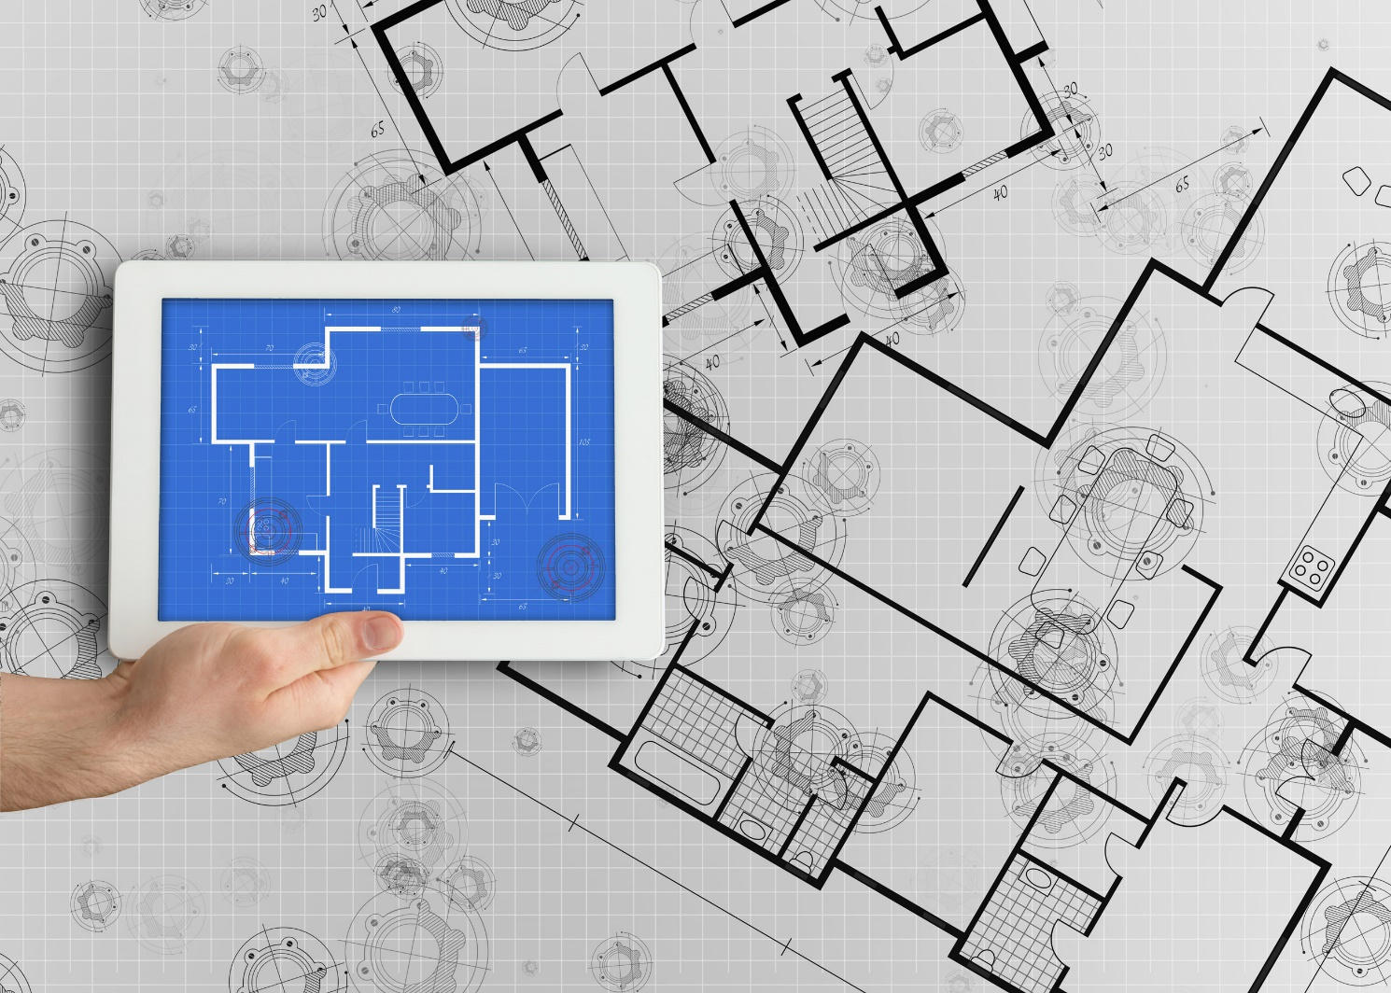
v

Integrated Supplier Transaction Guideline
July 2022

INTERNAL



Table of Contents
Version History 3
Honeywell Mapping Requirements and Deltas 4
Honeywell Detailed Specifications and Requirements 5
Scope 5
Purchase Order Details 5
Order Confirmation Details 6
Invoice Details 6
Supplemental Documentation 9
SAP Ariba customer Support for Suppliers 10

Version History
This log is updated each time this Process Document is updated. The log identifies the version number, the date the version was completed, the author of the changes, and a brief description of the changes.

Version | Date | Description
1.0 | 07/2022 | Initial Version of Document

Honeywell Mapping Requirements and Deltas

Deltas
In the following excel workbooks you will find baseline cXML and EDI transactions accepted by the Ariba Network with the additional requirements for Honeywell noted in red.

cXML Delta: EDI Delta:
The following is a summary of the requirements that are unique to Honeywell’s procurement environment, as detailed in the Excel Delta’s document.

Purchase Order Specifics (Tab 1)
- Payment terms will be sent on all POs.
- Supplier Part ID and Buyer Part ID may or may not be populated in Honeywell POs. When not available, Supplier Part ID will be empty. This will prevent EDI suppliers from transacting through our Legacy EDI platform and a connection through CIG will need to be created.
- Honeywell non-catalog POs will not contain the isAdHoc attribute or any other difference from catalog POs.
- Honeywell POs will have tax information at the line. Invoices may fail if the tax information in the invoice differs from the PO.
- Honeywell POs will have Control Keys.
- Honeywell POs will have Schedule Lines with requested delivery date. This information is required in the Order Confirmation.
- Honeywell will send Service and Blanket POs as material POs with high quantity and unit price = 1.

Invoice Specifics (Tab 2)
- Required addresses and IDs: Remit To.
- Payment terms may be omitted but they will need to match the PO if sent.
- Invoices may be backdated up to 2 days.
- Suppliers are required to provide their Tax ID on invoices.
- Shipping and Special Handling costs are supported at the summary level.
- Invoice numbers may be reused in case of rejection and failure.
- A PDF version of the invoice is required to be attached.
- Tax is required at the line. A summary tax amount is required on all invoices even if that amount is zero dollars.

Order Confirmation Specifics (Tab 3)
- Schedule Lines are required in order confirmations.
- Honeywell has automatic email reminders configured for POs that have not been confirmed or shipped.

Credit Memo (Tab 5)

Receipt Request (Tab 6)

- Honeywell will send receipts for items received.

Payment Remittance

- In the future Honeywell will send Payment Remittance transactions which can be integrated.

Transaction Validation Rules

Please note, Honeywell has configured custom validation rules on the Ariba Network which apply specifically to POs, Order Confirmations and PO based Invoices. Review these settings from your supplier account on the Ariba Network.

Honeywell Detailed Specifications and Requirements

Scope

Honeywell Prod ANID: AN01785206284
Honeywell Test ANID: AN01785206284-T

Required Transactions
  - Purchase Order
  - Order Confirmation
  - Invoice

Purchase Order Details

Purchase Order Types Supported | Purchase Order Types Not Supported
New POs
Change/cancel POs
Non-catalog POs
POs with attachments
Service POs as material PO
Blanket POs (BPO’s)
Table 1 - Purchase Order Types Supported/Not Supported

Legacy Orders (Cut-Over Process)

Each supplier will have its own cutover process. This will need to be discussed with each supplier individually.

Ship To Address

  - Honeywell PO will send Ship To address at header level
  - Honeywell PO will contain Ship To address IDs however the same address ID can be shared across multiple physical addresses. The address information will need to be mapped by the supplier.

Order Confirmation Details

Honeywell requires Order Confirmation. Supported methods of providing them are:
  - cXML
  - EDI
  - Online

Please note that Honeywell has enabled automatic email reminders for orders that have not been confirmed.

Invoice Details

Invoice Types Supported | Invoice Types Not Supported
Individual Detail Invoice: applies against a single PO referencing line items; line items may be material items or service items. | Invoice against service PO
Partial invoice: Invoice against a portion of the items on a PO. | Non-PO Invoice: invoice against PO not transacted via the Ariba Network
Invoice against material PO | Non-PO invoice against contract or master agreement
Line level credit supported by negative quantity at item level and positive unit price | Invoice against Blanket PO
lineLevelCreditMemo (cXML 1.2.018 and higher) invoice purpose set to “lineLevelCreditMemo” | Header Credit Memo
Duplicate Invoice: invoice numbers may be reuse in case of reject/fail of original invoice. | Debit Memo
 | Cancel Invoice
 | Invoice against PCard
 | Header Invoice: single invoice applying to single PO without item details
Table 2 - Invoice Types Supported/Not Supported

Tax Requirements

- Tax is required at the line level.

- A summary tax amount is required on all invoices even if that amount is zero dollars.

- The tax category in the invoice needs to match the tax category sent in the Purchase Order. Please refer to the deltas for details.

Remit To Address Information

  - Customer will provide the Remit-To IDs and addresses to suppliers as part of the on-boarding process. Invoices will be rejected that have incorrect Remit-To IDs.

  - Remit-To configuration may be viewed in the Settlement configuration section of your supplier account on AN. Contact Customer directly for your Remit-To ID if it is not present on your supplier account, or if you have any questions regarding your Remit-To ID.

  - Suppliers should notify Customer of any changes to their Remit-To address information.
Shipping and Special Handling Fees

Shipping and special handling charges are supported at the summary level.

Line Level Validation
- The following line level data cannot be changed from PO to Invoice.
  - Currency for Unit Price
  - Unit Price
  - Unit of Measure
  - Item Quantity Overage
  - Part Number

Supplemental Documentation

This document contains Honeywell specific information regarding transaction requirements. Information in this document does not cover the complete technical aspects of integrating with the Ariba Network.

Below are three sections for supplemental documentation to be used with this document for cXML, EDI x12 or PIDX transaction formats. Only refer to the section that pertains to the format your organization with be sending or receiving.

cXML Supplemental Documentation
New cXML supplier to Ariba Network must:
- Support a DTD (document type definition) validation tool internally and download the document type definitions (DTD’s) for all supported transactions.
- Support HTTPS protocol. Ariba supports HTTPS (not HTTP) only for cXML transactions.
- Review the cXML Solutions Guide and cXML User Guides.

cXML Document Type Definitions (DTD’s)
- http://cxml.org Download InvoiceDetail.zip for the InvoiceDetailRequest.dtd.
- http://cxml.org Download cXML.DTD for the OrderRequest
- http://cxml.org Download Fulfill.dtd for ConfirmationRequest/ShipNoticeRequest

SAP Ariba Cloud Integration Gateway (CIG)
Information in this document does not cover the complete technical aspects of integrating with the SAP Ariba Cloud Integration Gateway (CIG).

Below is a list of supplemental documentation to be used with this document for CIG connectivity, CIG EDI x12 and PIDX transaction file formats. These documents can be viewed or downloaded from the CIG Resource Portal. How to login to SAP Cloud Integration Gateway.

New Cloud Integration Gateway Supplier
- Cloud Integration Portal Guide (aka. CIG “How to Guide”)

EDI x12 Supplemental Documentation via SAP Ariba Cloud Integration Gateway
- SAP Ariba PO850 4010 Purchase Order
- SAP Ariba PC860 4010 Purchase Order Change
- SAP Ariba PR855 4010 PO Acknowledgment (Order Confirmation)
- SAP Ariba IN810 4010 Invoice
- SAP Ariba SH856 4010 Ship Notice
- SAP Ariba RA820 4010 Remittance Advice
- SAP Ariba AG824 4010 Application Advice (inbound)
- SAP Ariba AG824 4010 Application Advice (outbound)
- SAP Ariba FA997 4010 Functional Acknowledgment (inbound)
- SAP Ariba FA997 4010 Functional Acknowledgment (outbound)

PIDX Supplemental Documentation via SAP Ariba Cloud Integration Gateway
- SAP Ariba PIDX OrderCreate OrderChange 1.61 Outbound
- SAP Ariba PIDX OrderResponse 1.61 Inbound
- SAP Ariba PIDX Invoice 1.61 Inbound
- SAP Ariba PIDX InvoiceResponse
- SAP Ariba PIDX Receipt Outbound

If you do not yet have user access to CIG, the SAP Ariba Supplier Integration Specialist will forward these documents. Once user access is obtained, the current CIG documentation may be viewed in or downloaded from the CIG Resources section.

SAP Ariba customer Support for Suppliers

How to utilize Help Center and access Customer Support
At SAP Ariba, our goal is to empower Suppliers with the information and tools they need to seamlessly navigate through Ariba Solutions. You can find the answers you need about Ariba products in the SAP Ariba Help Center. You can also contact SAP Ariba Support directly through the Help Center, when necessary.

Access the Help Center After Supplier Account Login
Login to your account (supplier.ariba.com) look to the top right-hand side of your screen and click on the
 icon to view the Help Center panel.

Using the Help Center
The Help Center is the first place to start if you have questions about any Ariba Solution. You can search for answers to functional and navigational questions from the search bar or view Documentation.
The following tutorials are helpful when you’re getting started:
  - Supplier Basics
  - Invoices

Still need more help? Contact Customer Support
If you don’t find your answer after searching, you can request direct support via the Help Center webform.

To Request Direct Support:
- Clicking the  icon in the top-right corner will take you to Help Center Home.
- Select Contact Us on the menu bar.
- Search for your issue in the I need help with search bar.
Based on your search, FAQ and Support Help articles will appear for review. If the guided content does not resolve the issue, click on Something else from the options menu at the bottom.
- A pop window will appear at the bottom with “Can’t find what you’re looking for?” message. Click on the Contact Us button to the right.
- The Service Request form will appear, fill it out including all required fields and contact information. Provide details and attached screen shots of any error messages. Click on One last step button at the bottom right.
- Next window will appear with options for contact via Email, Phone or Live chat. Select the preferred contact method and click on Submit button at the bottom right.

