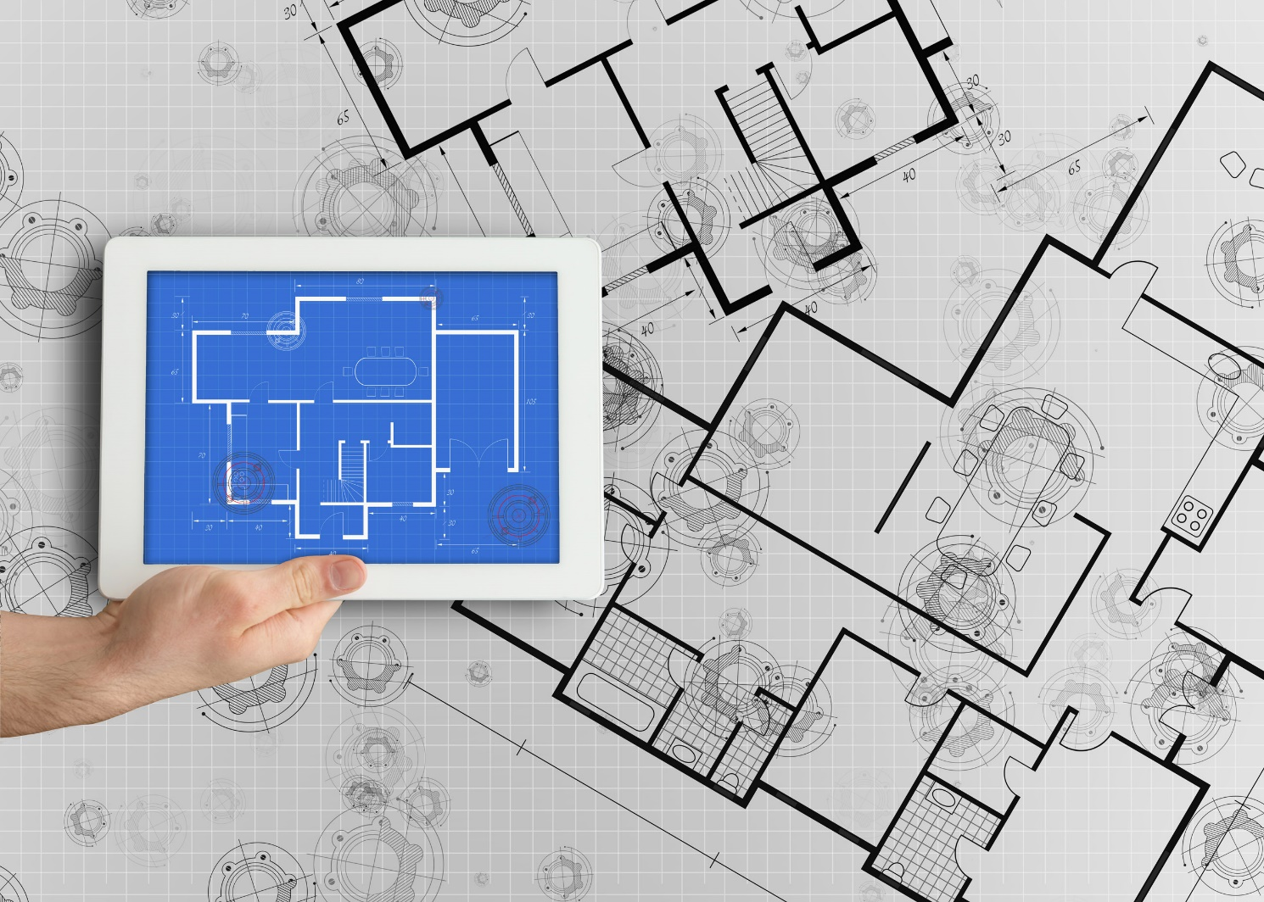

Integrated Supplier Transaction Guideline
January 2022

INTERNAL

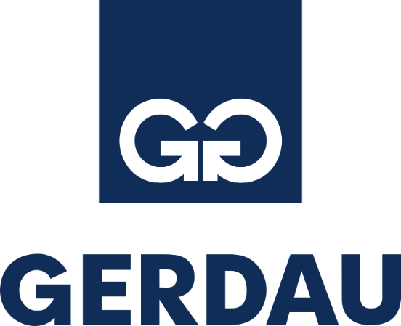

Table of Contents
Version History 3
Gerdau Mapping Requirements and Deltas 4
Gerdau Detailed Specifications and Requirements 5
Scope 5
Purchase Order Details 5
Order Confirmation Details 5
Ship Notice Details 5
Invoice Details 6
Supplemental Documentation 7
SAP Ariba customer Support for Suppliers 8

Version History
This log is updated each time this Process Document is updated. The log identifies the version number, the date the version was completed, the author of the changes, and a brief description of the changes.

Version | Date | Author | Description
1.0 | 01/2022 | Shirley Duong, SAP Ariba | Initial Version of Document

Gerdau Mapping Requirements and Deltas

Deltas
In the following excel workbooks you will find baseline cXML transactions accepted by the Ariba Network with the additional requirements for Gerdau noted below.

cXML Delta:
The following is a summary of the requirements that are unique to Gerdau’s procurement environment, as detailed in the Excel Delta’s document.

Purchase Order Specifics (Tab 1)
- Payment terms will be sent on all POs
- Ship To address will be sent at the header
- Estimated taxes will be sent at the line item
- Control keys will be sent at the line item for OC and ASN

Invoice Specifics (Tab 2) *PENDING

Order Confirmation Specifics (Tab 3)
- No rejections are allowed (header or line); Supplier to reach out to Gerdau if there is an item that cannot be fulfilled

Ship Notice Specifics (Tab 4)
- Delivery terms and transport information may be added

Credit Memo (Tab 5) *PENDING

Additional Tabs for: Service Invoice *PENDING

Transaction Validation Rules

Please note, Gerdau has configured custom validation rules on the Ariba Network which apply specifically to POs, Order Confirmations, Ship Notices, and PO based Invoices. Review these settings from your supplier account on the Ariba Network.

Gerdau Detailed Specifications and Requirements

Scope

Gerdau Prod ANID: AN01512756408
Gerdau Test ANID: AN01512756408-T

Required Transactions
  - Purchase Order

Optional Transactions *strongly preferred by Gerdau
  - Order Confirmation
  - Advanced Ship Notice
  - Invoice *Note: Invoices will be required at a later date

Purchase Order Details

Purchase Order Types Supported | Purchase Order Types Not Supported
New POs | Blanket POs (BPO’s)
Change/cancel POs
Non-catalog POs
POs with attachments
Service POs
Table 1 - Purchase Order Types Supported/Not Supported

Ship To Address

  - Gerdau PO will send Ship To address at header level
  - Gerdau PO will contain Ship To address IDs.

Order Confirmation Details

Gerdau does not require Order Confirmation. Supported methods of providing them are:
  - cXML
  - Online

Ship Notice Details

Gerdau does not require Advanced Ship Notices. Supported methods of providing them are:
  - cXML
  - Online

Invoice Details

Invoice Types Supported | Invoice Types Not Supported
Individual Detail Invoice: applies against a single PO referencing line items; line items may be material items or service items. | Non-PO Invoice: invoice against PO not transacted via the Ariba Network
Partial invoice: Invoice against a portion of the items on a PO. | Non-PO invoice against contract or master agreement
Invoice against material PO | Invoice against Blanket PO
Invoice against service PO | Line level credit supported by negative quantity at item level and positive unit price
lineLevelCreditMemo (cXML 1.2.018 and higher) invoice purpose set to “lineLevelCreditMemo” | Debit Memo
Header Credit Memo | Invoice against PCard
Cancel Invoice | Duplicate Invoice: invoice numbers may be reuse in case of reject/fail/cancel of original invoice
 | Header Invoice: single invoice applying to single PO without item details
Table 2 - Invoice Types Supported/Not Supported

Tax Requirements *PENDING

- Tax is supported at the line level or summary level or both.

- A summary tax amount is required on all invoices even if that amount is zero dollars.

Remit To Address Information
  - Remit To address information is not required on the invoice.

Shipping and Special Handling Fees *PENDING

  - Shipping and special handling charges are supported at the line level or summary level or both.

  - Shipping and special handling may be submitted as separate line items.

- If yes, shipping and special handling is supported as a single SERVICE line for ALL special handling charges and a single SERVICE line for ALL shipping charges.

Line Level Validation
- The following line level data cannot be changed from PO to Invoice.
  - Currency for Unit Price
  - Unit Price
  - Unit of Measure
  - Item Quantity Overage
  - Part Number

Supplemental Documentation

This document contains Gerdau specific information regarding transaction requirements. Information in this document does not cover the complete technical aspects of integrating with the Ariba Network.

Below are three sections for supplemental documentation to be used with this document for cXML, EDI x12 or PIDX transaction formats. Only refer to the section that pertains to the format your organization with be sending or receiving.

cXML Supplemental Documentation
New cXML supplier to Ariba Network must:
- Support a DTD (document type definition) validation tool internally and download the document type definitions (DTD’s) for all supported transactions.
- Support HTTPS protocol. Ariba supports HTTPS (not HTTP) only for cXML transactions.
- Review the cXML Solutions Guide and cXML User Guides.

cXML Document Type Definitions (DTD’s)
- http://cxml.org Download InvoiceDetail.zip for the InvoiceDetailRequest.dtd.
- http://cxml.org Download cXML.DTD for the OrderRequest
- http://cxml.org Download Fulfill.dtd for ConfirmationRequest/ShipNoticeRequest

SAP Ariba Cloud Integration Gateway (CIG)
Information in this document does not cover the complete technical aspects of integrating with the SAP Ariba Cloud Integration Gateway (CIG).

Below is a list of supplemental documentation to be used with this document for CIG connectivity, CIG EDI x12 and PIDX transaction file formats. These documents can be viewed or downloaded from the CIG Resource Portal. How to login to SAP Cloud Integration Gateway.

New Cloud Integration Gateway Supplier
- Cloud Integration Portal Guide (aka. CIG “How to Guide”)

EDI x12 Supplemental Documentation via SAP Ariba Cloud Integration Gateway
- SAP Ariba PO850 4010 Purchase Order
- SAP Ariba PC860 4010 Purchase Order Change
- SAP Ariba PR855 4010 PO Acknowledgment (Order Confirmation)
- SAP Ariba IN810 4010 Invoice
- SAP Ariba SH856 4010 Ship Notice
- SAP Ariba RA820 4010 Remittance Advice
- SAP Ariba AG824 4010 Application Advice (inbound)
- SAP Ariba AG824 4010 Application Advice (outbound)
- SAP Ariba FA997 4010 Functional Acknowledgment (inbound)
- SAP Ariba FA997 4010 Functional Acknowledgment (outbound)

PIDX Supplemental Documentation via SAP Ariba Cloud Integration Gateway
- SAP Ariba PIDX OrderCreate OrderChange 1.61 Outbound
- SAP Ariba PIDX OrderResponse 1.61 Inbound
- SAP Ariba PIDX Invoice 1.61 Inbound
- SAP Ariba PIDX InvoiceResponse
- SAP Ariba PIDX Receipt Outbound

If you do not yet have user access to CIG, the SAP Ariba Supplier Integration Specialist will forward these documents. Once user access is obtained, the current CIG documentation may be viewed in or downloaded from the CIG Resources section.

SAP Ariba customer Support for Suppliers

How to utilize Help Center and access Customer Support
At SAP Ariba, our goal is to empower Suppliers with the information and tools they need to seamlessly navigate through Ariba Solutions. You can find the answers you need about Ariba products in the SAP Ariba Help Center. You can also contact SAP Ariba Support directly through the Help Center, when necessary.

Access the Help Center After Supplier Account Login
Login to your account (supplier.ariba.com) look to the top right-hand side of your screen and click on the
icon to view the Help Center panel.

Using the Help Center
The Help Center is the first place to start if you have questions about any Ariba Solution. You can search for answers to functional and navigational questions from the search bar or view Documentation.
The following tutorials are helpful when you’re getting started:
  - Supplier Basics
  - Invoices

Still need more help? Contact Customer Support
If you don’t find your answer after searching, you can request direct support via the Help Center webform.

To Request Support:
  - Click the icon in the bottom-right corner of the expanded Help Center. After clicking, you will see a new window titled Help Center Home.
  - Select Contact Us on the menu bar.
  - Search for your issue in the I need help with search bar.
Based on your search, FAQ and Support Help articles will appear for review. If the guided content does not resolve the issue, click on Something else then Contact Us at the bottom of the screen.

SAP Ariba Customer Support Help Form
- Send a written online request to SAP Ariba Customer Support via a short webform.
- Provide a Short Description, Details, and Attachment to ensure a fast and accurate response.

