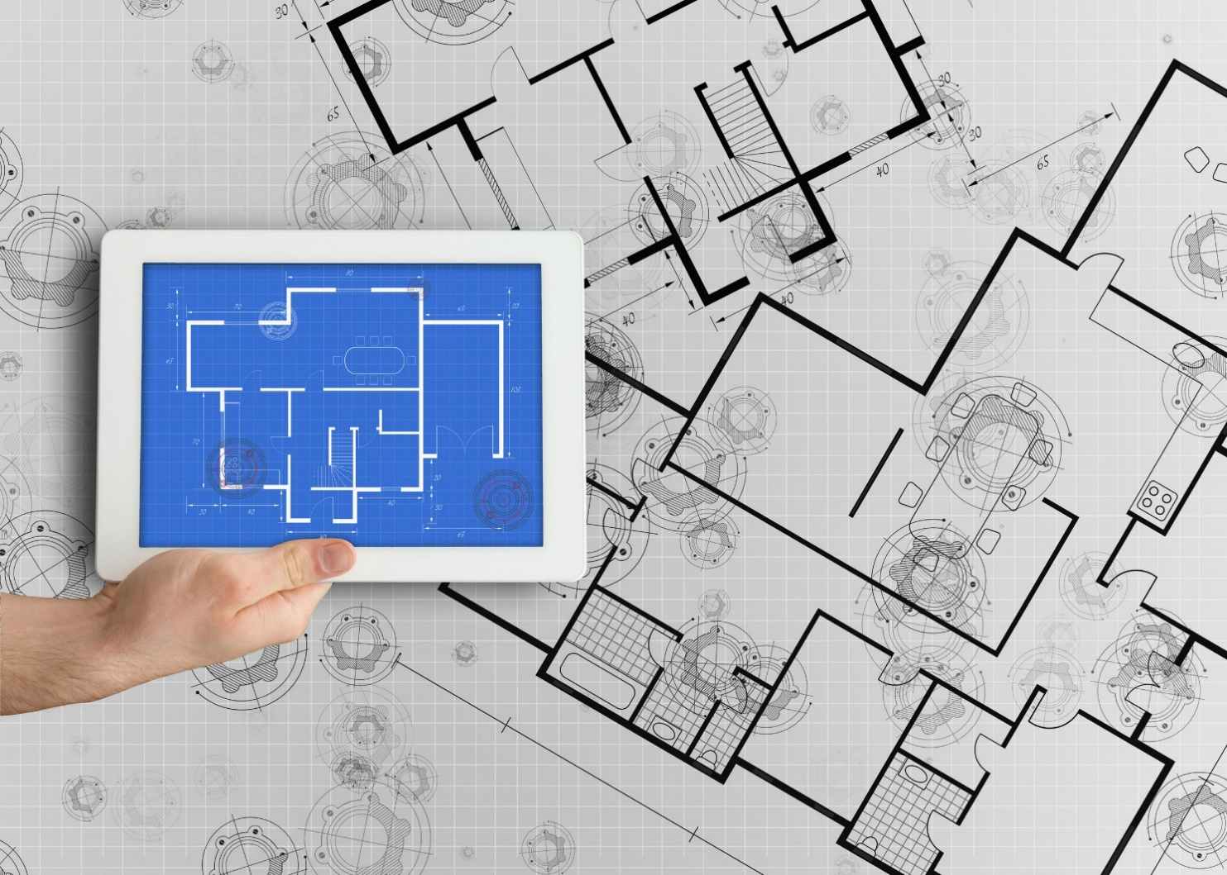

**Integrated Supplier Transaction Guideline**

January 2023

****

Table of Contents

[Version History 3](#_Toc100675060)

[Abbott Laboratories Mapping Requirements and Deltas 4](#_Toc100675061)

[Abbott Laboratories Detailed Specifications and Requirements 6](#_Toc100675062)

[Scope 6](#_Toc100675063)

[Purchase Order Details 6](#_Toc100675064)

[Order Confirmation Details 7](#_Toc100675065)

[Ship Notice Details 7](#_Toc100675066)

[Invoice Details 7](#_Toc100675067)

[Supplemental Documentation 9](#_Toc100675068)

[SAP Ariba customer Support for Suppliers 10](#_Toc100675069)

# Version History

This log is updated each time this Process Document is updated. The log identifies the version number, the date the version was completed, the author of the changes, and a brief description of the changes.

|  |  |  |  |
| --- | --- | --- | --- |
| Version | Date | Author | Description |
| 1.0 | 03/2022 | Matt Dallas | Initial Version of Document |
| 1.1 | 01/2023 | Matt Dallas | Canada Added to Scope |

# Abbott Laboratories Mapping Requirements and Deltas

**Deltas**

In the following excel workbooks you will find baseline cXML and EDI transactions accepted by the Ariba Network with the additional requirements for Abbott Laboratories noted in **blue.**

**cXML Delta:** ** **EDI Delta**: **  
The following is a summary of the requirements that are unique to the Abbott Laboratories procurement environment, as detailed in the Excel Delta’s document.

**Purchase Order Specifics (Tab 1)**

* Change POs are allowed
* Cancels are allowed before any goods are shipped
* In Scope POs include: Catalog, Non-Catalog, Canada POs, and Service POs
* Attachments may be used, especially with orders that include Quotes
* UNUOM used, but there may be a few custom units of measure that would be discussed during supplier call
* Ship To sent at the Header level
  + Ship To Address IDs Required
  + Deliver To will be used
  + Ad-Hoc addresses may be used and will have an “ADBUYER” prefix
* Payment terms will be sent
* Taxes will be provided on the order
* No Control Keys or Schedule Lines
* For Non-Catalog and Service orders, “Not Available” will likely be sent as the supplier part ID with a detailed description included. A buyer part ID or supplier auxiliary part ID may also be referenced.

**Order Confirmation Specifics (Tab 2)**

* Order Confirmations are Recommended
* Rejections Require a Reason
* Shipping and Delivery Dates Recommended
* In special circumstances, Tolerances can be implemented
* Comments Recommended for any Changes

**Ship Notice Specifics (Tab 3)**

* Advance Ship Notices are Recommended
* Cancels Allowed
* Shipping and Delivery Date Recommended
* In special circumstances, Tolerances can be implemented
* Delivery and Transport information allowed

**Invoice Specifics**

* Partial Invoices Allowed
* Cancel Invoices Allowed
* Service Invoices in Scope
  + No SES required
* Non-PO Invoices and Invoices against Contract considered not in scope
* Invoice Number max length is 16 characters
  + No special characters or spaces allowed
  + Invoice numbers can be reused, even if it failed, was rejected or was cancelled
* No Backdating or future dating allowed
* Payment Terms Required and must match PO
* Bill To ID and Address Required, Ship To ID and Address Required, Remit To Address Required, Ship From Address Required, Sold To Address Required and From Address Required
  + Remit To Address must match exactly what Abbott Laboratories has on file in ERP
* Attachments allowed
* Line-item Descriptions Required
* Taxes can be at the summary level or line level
  + Tax category, Percentage rate, tax amount, and taxable amount required
* Shipping and Special Handling charges supported at summary level
* Canada invoices require a Registration Number to be included

**Credit Memo Specifics**

* Line Level Credit Memo in scope
* Header Credit Memo in scope
* Requires a Reason
* Reference to original invoice Required

**Transaction Validation Rules**

Please note, Abbott Laboratories has configured custom validation rules on the Ariba Network which apply specifically to POs, Order Confirmations, Ship Notices, Invoices and Credit Memos. **Review these settings from your supplier account on the Ariba Network**.

# Abbott Laboratories Detailed Specifications and Requirements

## Scope

Abbott Laboratories Prod ANID: AN01692968131

Abbott Laboratories Test ANID: AN01692968131-T

Required Transactions

* + Purchase Order
  + Invoices

**Recommended Transactions**

* + Order Confirmations
  + Advanced Ship Notice

## Purchase Order Details

|  |  |
| --- | --- |
| Purchase Order Types Supported | Purchase Order Types Not Supported |
| Change POs | **BPOs** |
| Non-Catalog POs | **Legacy Orders** |
| POs with attachments | **PCard POs** |
| Service POs |  |
| Cancel POs |  |
|  |  |

Table 1 - Purchase Order Types Supported/Not Supported

**Ship To Address**

* + Abbott Laboratories POs will have the Ship To address at the header level
  + Abbott Laboratories POs will have an Address IDs for the Bill To and Ship To
  + Abbott Laboratories POs will use the Deliver To field
  + Abbott Laboratories POs may use an Ad-Hoc address which will have an “ADBUYER” prefix

## Order Confirmation Details

Abbott Laboratories **does not** require Order Confirmations. Supported methods of providing them are:

* + cXML
  + EDI
  + Online
  + Email to requestor outside of Ariba Network

## Ship Notice Details

Abbott Laboratories **does not** require Advanced Ship Notices. Supported methods of providing them are:

* + cXML
  + EDI
  + Online
  + Email to requestor outside of Ariba Network

## Invoice Details

Invoices are in scope

|  |  |
| --- | --- |
| Invoice Types Supported | Invoice Types Not Supported |
| Individual Detail Invoice: applies against a single PO referencing line items; line items may be material items or service items. | Invoice against Blanket PO |
| Partial invoice: Invoice against a portion of the items on a PO. | Invoice against PCard |
| Invoice against material PO | Header Invoice: single invoice applying to single PO without item details |
| Invoice against service PO | Non-PO Invoice: invoice against PO not transacted via the Ariba Network |
| Line level credit supported by negative quantity at item level and positive unit price | Non-PO invoice against contract or master agreement |
| lineLevelCreditMemo (cXML 1.2.018 and higher) invoice purpose set to “lineLevelCreditMemo” | Debit Memo |
| Header Credit Memo |  |
| Duplicate Invoice: invoice numbers may be reused in case of failed/cancel of original invoice |  |
| Cancel Invoices |  |
|  |  |
|  |  |
|  |  |
|  |  |

Table 2 - Invoice Types Supported/Not Supported

**Tax Requirements**

* Tax is supported at the summary and/or line level
* Tax details must include Category, Percentage Rate, Tax Amount, and Taxable Amount

**Remit to Address Information**

* Remit To address information is required on the invoice.

**Shipping and Special Handling Fees**

* + Shipping and special handling charges are supported at the Summary and/or Line level

**Line Level Validation**

* The following line level data cannot be changed from PO to Invoice.
  + Currency for Unit Price
  + Unit of Measure
  + Part Number
  + Auxiliary Part Number
  + Line Numbers

# Supplemental Documentation

This document contains Abbott Laboratoriesspecific information regarding transaction requirements. Information in this document does not cover the complete technical aspects of integrating with the Ariba Network.

Below are three sections for supplemental documentation to be used with this document for cXML, EDI x12 or PIDX transaction formats. Only refer to the section that pertains to the format your organization with be sending or receiving.

**cXML Supplemental Documentation**

New cXML supplier to Ariba Network must:

1. Support a DTD (document type definition) validation tool internally and download the document type definitions (DTD’s) for all supported transactions.
2. Support HTTPS protocol. Ariba supports HTTPS (not HTTP) only for cXML transactions.
3. Review the cXML Solutions Guide and cXML User Guides.

**cXML Document Type Definitions (DTD’s)**

* [http://cxml.org](http://cxml.org/) Download [InvoiceDetail.zip](http://xml.cxml.org/current/InvoiceDetail.zip) for the InvoiceDetailRequest.dtd.
* <http://cxml.org> Download cXML.DTD for the OrderRequest
* <http://cxml.org> Download Fulfill.dtd for ConfirmationRequest/ShipNoticeRequest

**SAP Ariba Cloud Integration Gateway (CIG)**

Information in this document does not cover the complete technical aspects of integrating with the SAP Ariba Cloud Integration Gateway (CIG).

Below is a list of supplemental documentation to be used with this document for CIG connectivity, CIG EDI x12 and PIDX transaction file formats. These documents can be viewed or downloaded from the CIG Resource Portal. How to login to [SAP Cloud Integration Gateway](https://help.sap.com/viewer/76c114b292d84c379d1626cff721acec/cloud/en-US/12c97457e7494a35ba53d84a1c6e0554.html).

**New Cloud Integration Gateway Supplier**

* Cloud Integration Portal Guide (aka. CIG “How to Guide”)

**EDI x12 Supplemental Documentation via SAP Ariba Cloud Integration Gateway**

* SAP Ariba PO850 4010 Purchase Order
* SAP Ariba PC860 4010 Purchase Order Change
* SAP Ariba PR855 4010 PO Acknowledgment (Order Confirmation)
* SAP Ariba IN810 4010 Invoice
* SAP Ariba SH856 4010 Ship Notice
* SAP Ariba RA820 4010 Remittance Advice
* SAP Ariba AG824 4010 Application Advice (inbound)
* SAP Ariba AG824 4010 Application Advice (outbound)
* SAP Ariba FA997 4010 Functional Acknowledgment (inbound)
* SAP Ariba FA997 4010 Functional Acknowledgment (outbound)

**PIDX Supplemental Documentation via SAP Ariba Cloud Integration Gateway**

* SAP Ariba PIDX OrderCreate OrderChange 1.61 Outbound
* SAP Ariba PIDX OrderResponse 1.61 Inbound
* SAP Ariba PIDX Invoice 1.61 Inbound
* SAP Ariba PIDX InvoiceResponse
* SAP Ariba PIDX Receipt Outbound

If you do not yet have user access to CIG, the SAP Ariba Supplier Integration Specialist will forward these documents. Once user access is obtained, the current CIG documentation may be viewed in or downloaded from the CIG Resources section.

# SAP Ariba customer Support for Suppliers

**How to utilize Help Center and access Customer Support**

At SAP Ariba, our goal is to empower Suppliers with the information and tools they need to seamlessly navigate through Ariba Solutions. You can find the answers you need about Ariba products in the SAP Ariba Help Center. You can also contact SAP Ariba Support directly through the Help Center, when necessary.

**Access the Help Center After Supplier Account Login**

[Login to your account](https://service.ariba.com/Supplier.aw) (supplier.ariba.com) look to the top right-hand side of your screen and click on the

 icon to view the Help Center panel.

**Using the Help Center**

The Help Center is the first place to start if you have questions about any Ariba Solution. You can search for answers to functional and navigational questions from the search bar or view Documentation.

The following tutorials are helpful when you’re getting started:

* + [Supplier Basics](https://sapvideoa35699dc5.hana.ondemand.com/?entry_id=1_5cifob4w" \t "_blank)
  + [Invoices](https://sapvideoa35699dc5.hana.ondemand.com/?entry_id=1_p6kxxwhq)

**Still need more help? Contact Customer Support**

If you don’t find your answer after searching, you can request direct support via the Help Center webform.

**To Request Direct Support:**

1. Clicking the  icon in the top-right corner will take you to Help Center Home.
2. Select **Contact Us** on the menu bar.
3. Search for your issue in the **I need help with** search bar.

Based on your search, FAQ and Support Help articles will appear for review. If the guided content does not resolve the issue, click on **Something else** from the options menu at the bottom.

1. A pop window will appear at the bottom with “**Can’t find what you’re looking for?**” message. Click on the **Contact Us** button to the right.
2. The Service Request form will appear, fill it out including all required fields and contact information.  Provide details and attached screen shots of any error messages.  Click on **One last step** button at the bottom right.
3. Next window will appear with options for contact via **Email**, **Phone** or **Live chat.** Select the preferred contact method and click on **Submit** button at the bottom right.